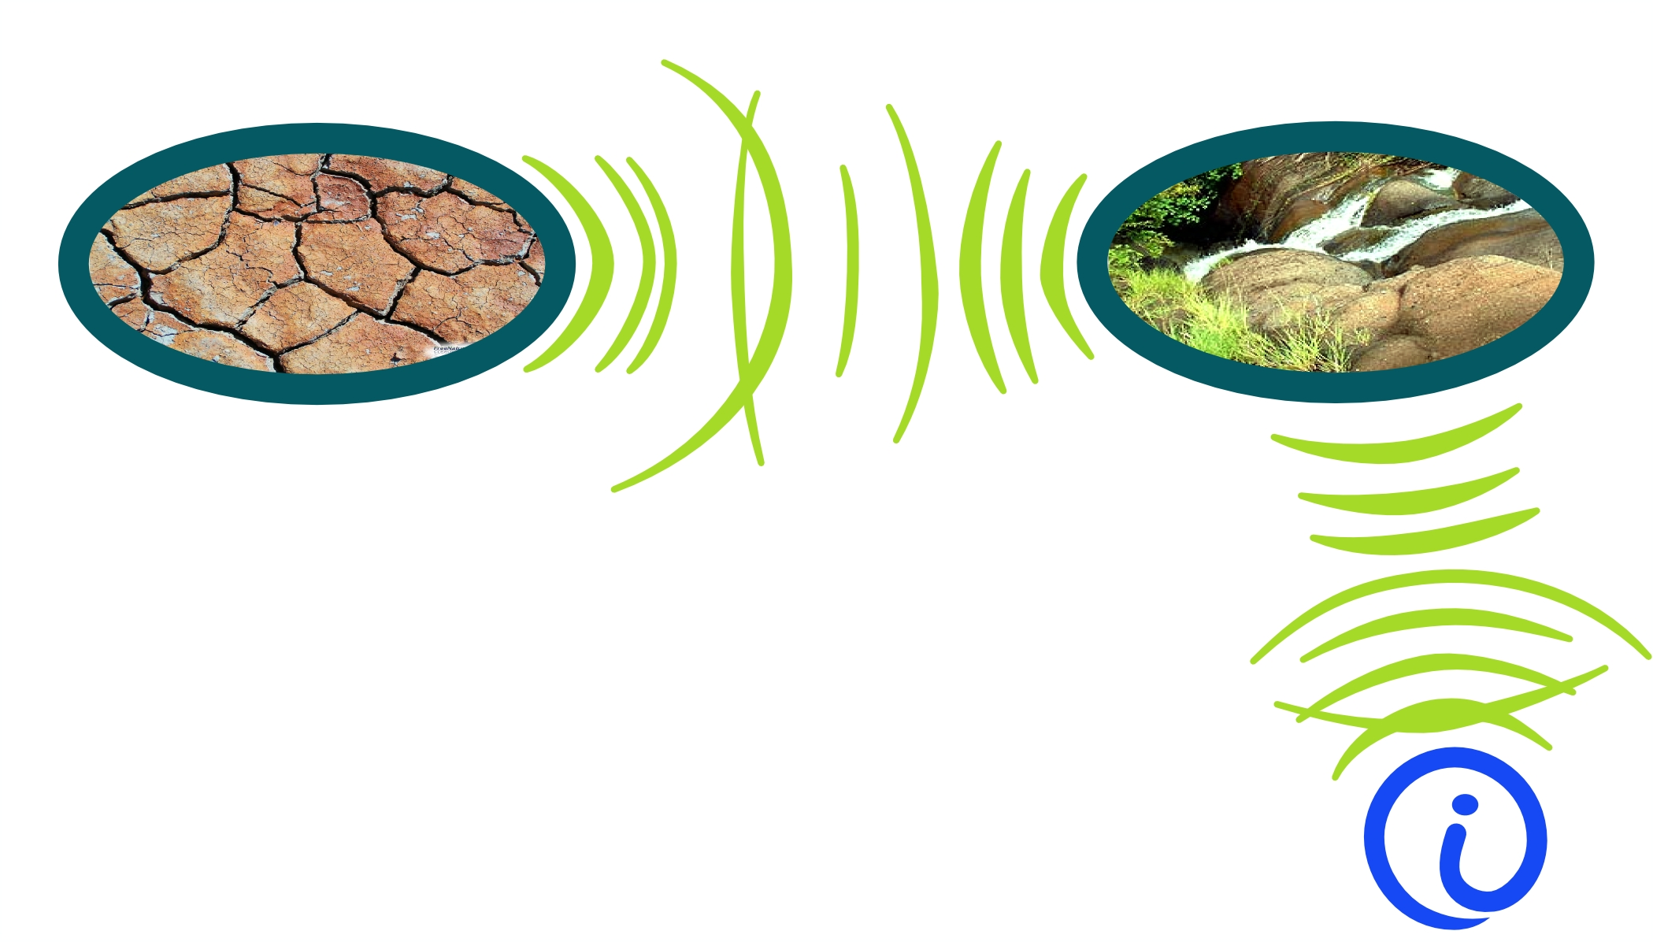
Pyzappa
Ecosensory
1218 W 39th St.
Austin Texas 78756
(512) 451-8207

Proposal to develop and deliver prototypes of an electroporator product capable of transforming bacteria for a target selling price of $125 in kit form.

There are three parts that are essential to a successful electroporator product. A user interface that is useful and simple, a voltage delivery system that can be user programmed as time varying voltage, and safety features to keep the high voltage away from human skin. The user interface planned is based on features of micropython, which will be running on the embedded microcontroller – USB port python prompt, status LEDs, command buttons. The voltage pulser will work from USB port power to charge a local LiFePO4 battery, then when commanded, boost voltage to 3000 Volts with a DC to DC 28 Volt stage, followed by a flyback 57:1 transformer switcher, and diode voltage 2X multiplier. The flyback switcher will be implemented with the microcontroller GPIOs driving FETs and bipolar transistors so as to merge a series of pulses into a jagged long pulse profile. The system safety designed in will stop danger and damage by high voltage via USB cables by not allowing a pulse to be delivered unless the USB cable is unplugged.

The sketches below show a concept of how this machine could evolve to have useful features without having too many confusing options:

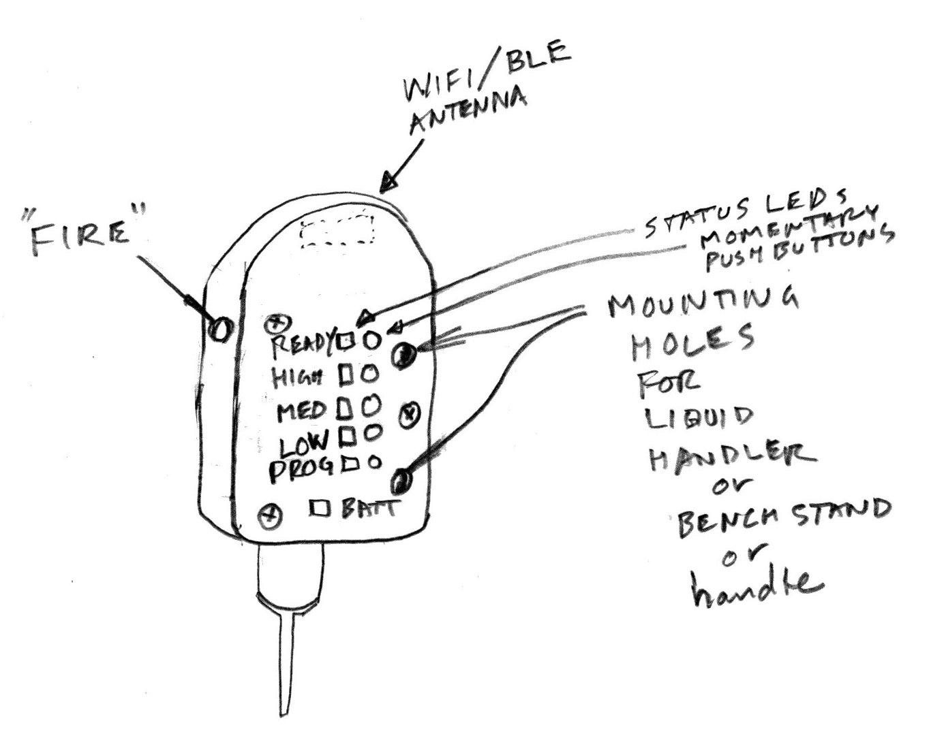
The button that fires the pulse will be away from other buttons so it is not pressed accidentally. The other buttons will each have a status LED next to them, and a label in English and a graphic. For the ready light, the button “gets it ready again” if the LED goes out; for MED HI LO PROG buttons the status LED immediately shows that the state changes when you push the button. The battery status LED has no button – to remedy a red battery status, you need to charge the battery more by plugging in the USB or the 28VDC wall wart supply. The 28V supply is not a path to computers/people safety issue, so it can be left plugged in all the time, (good for an automation application). The top of the housing has room for a WIFI radio antenna under the plastic for safely communicating to change states and fire the electroporator – good for automation also – but that won't be part of early rev 0.x or 1.0 pyzappas.

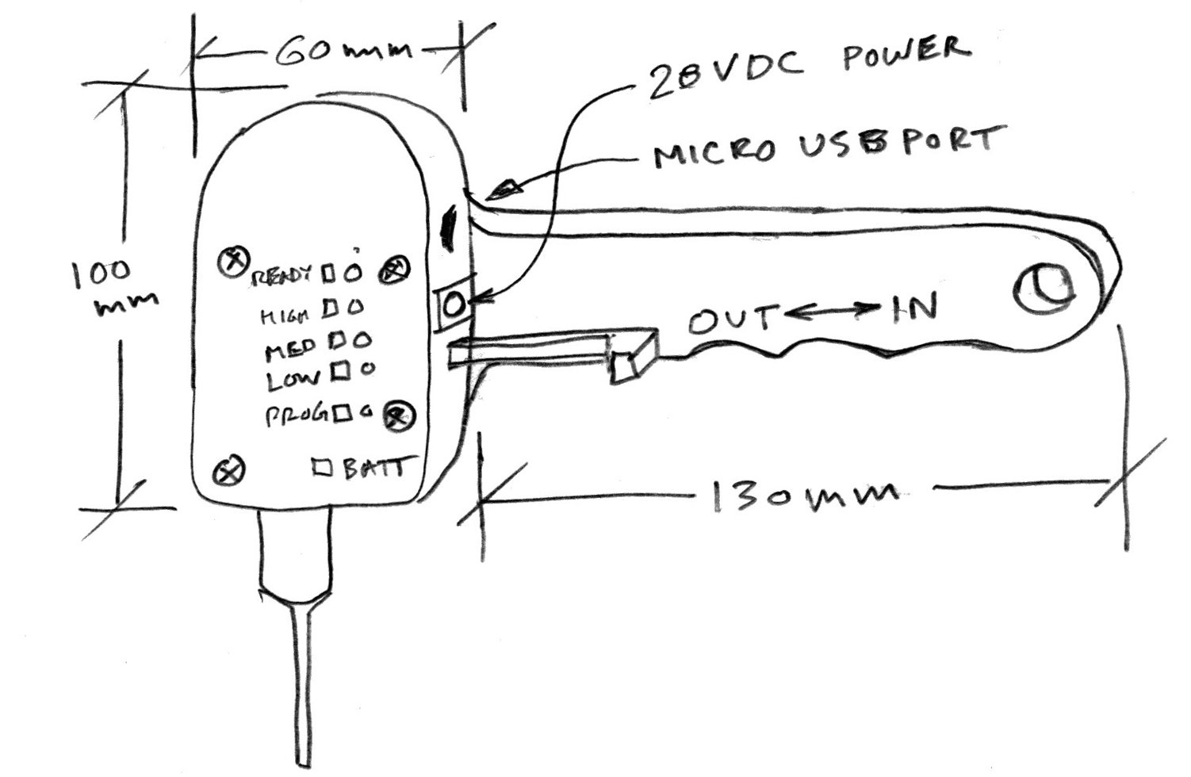
The pipette action is planned to be motorized later on and by a finger operated lever for rev 1.0 and not at all for rev 0.x pyzappas. Instead of a handle, a stand can be attached to set it on a table and move cell suspensions under it.

The circuits used for
pulse generating have been around for along time, but combining pulses to make a profile is not often seen. It will work well and be as reliable as most normal power supplies because the number of parts is low. The computer general purpose IO lines will be driving FETs so plenty of HV protection resistance in the lines is OK – no big slow down of signals. So if an FET blows, it won't take out the microcontroller.

The microcontroller planned is a STM32F030CCT6 which costs only $1.30 and can run micropython when some new platform definition work is done. If that work is too long to do for this project, another variant the STM32F401CBU6 which costs $2.8 will be used since it is already a defined micropython platform. Samples of these MCUs are in store now.
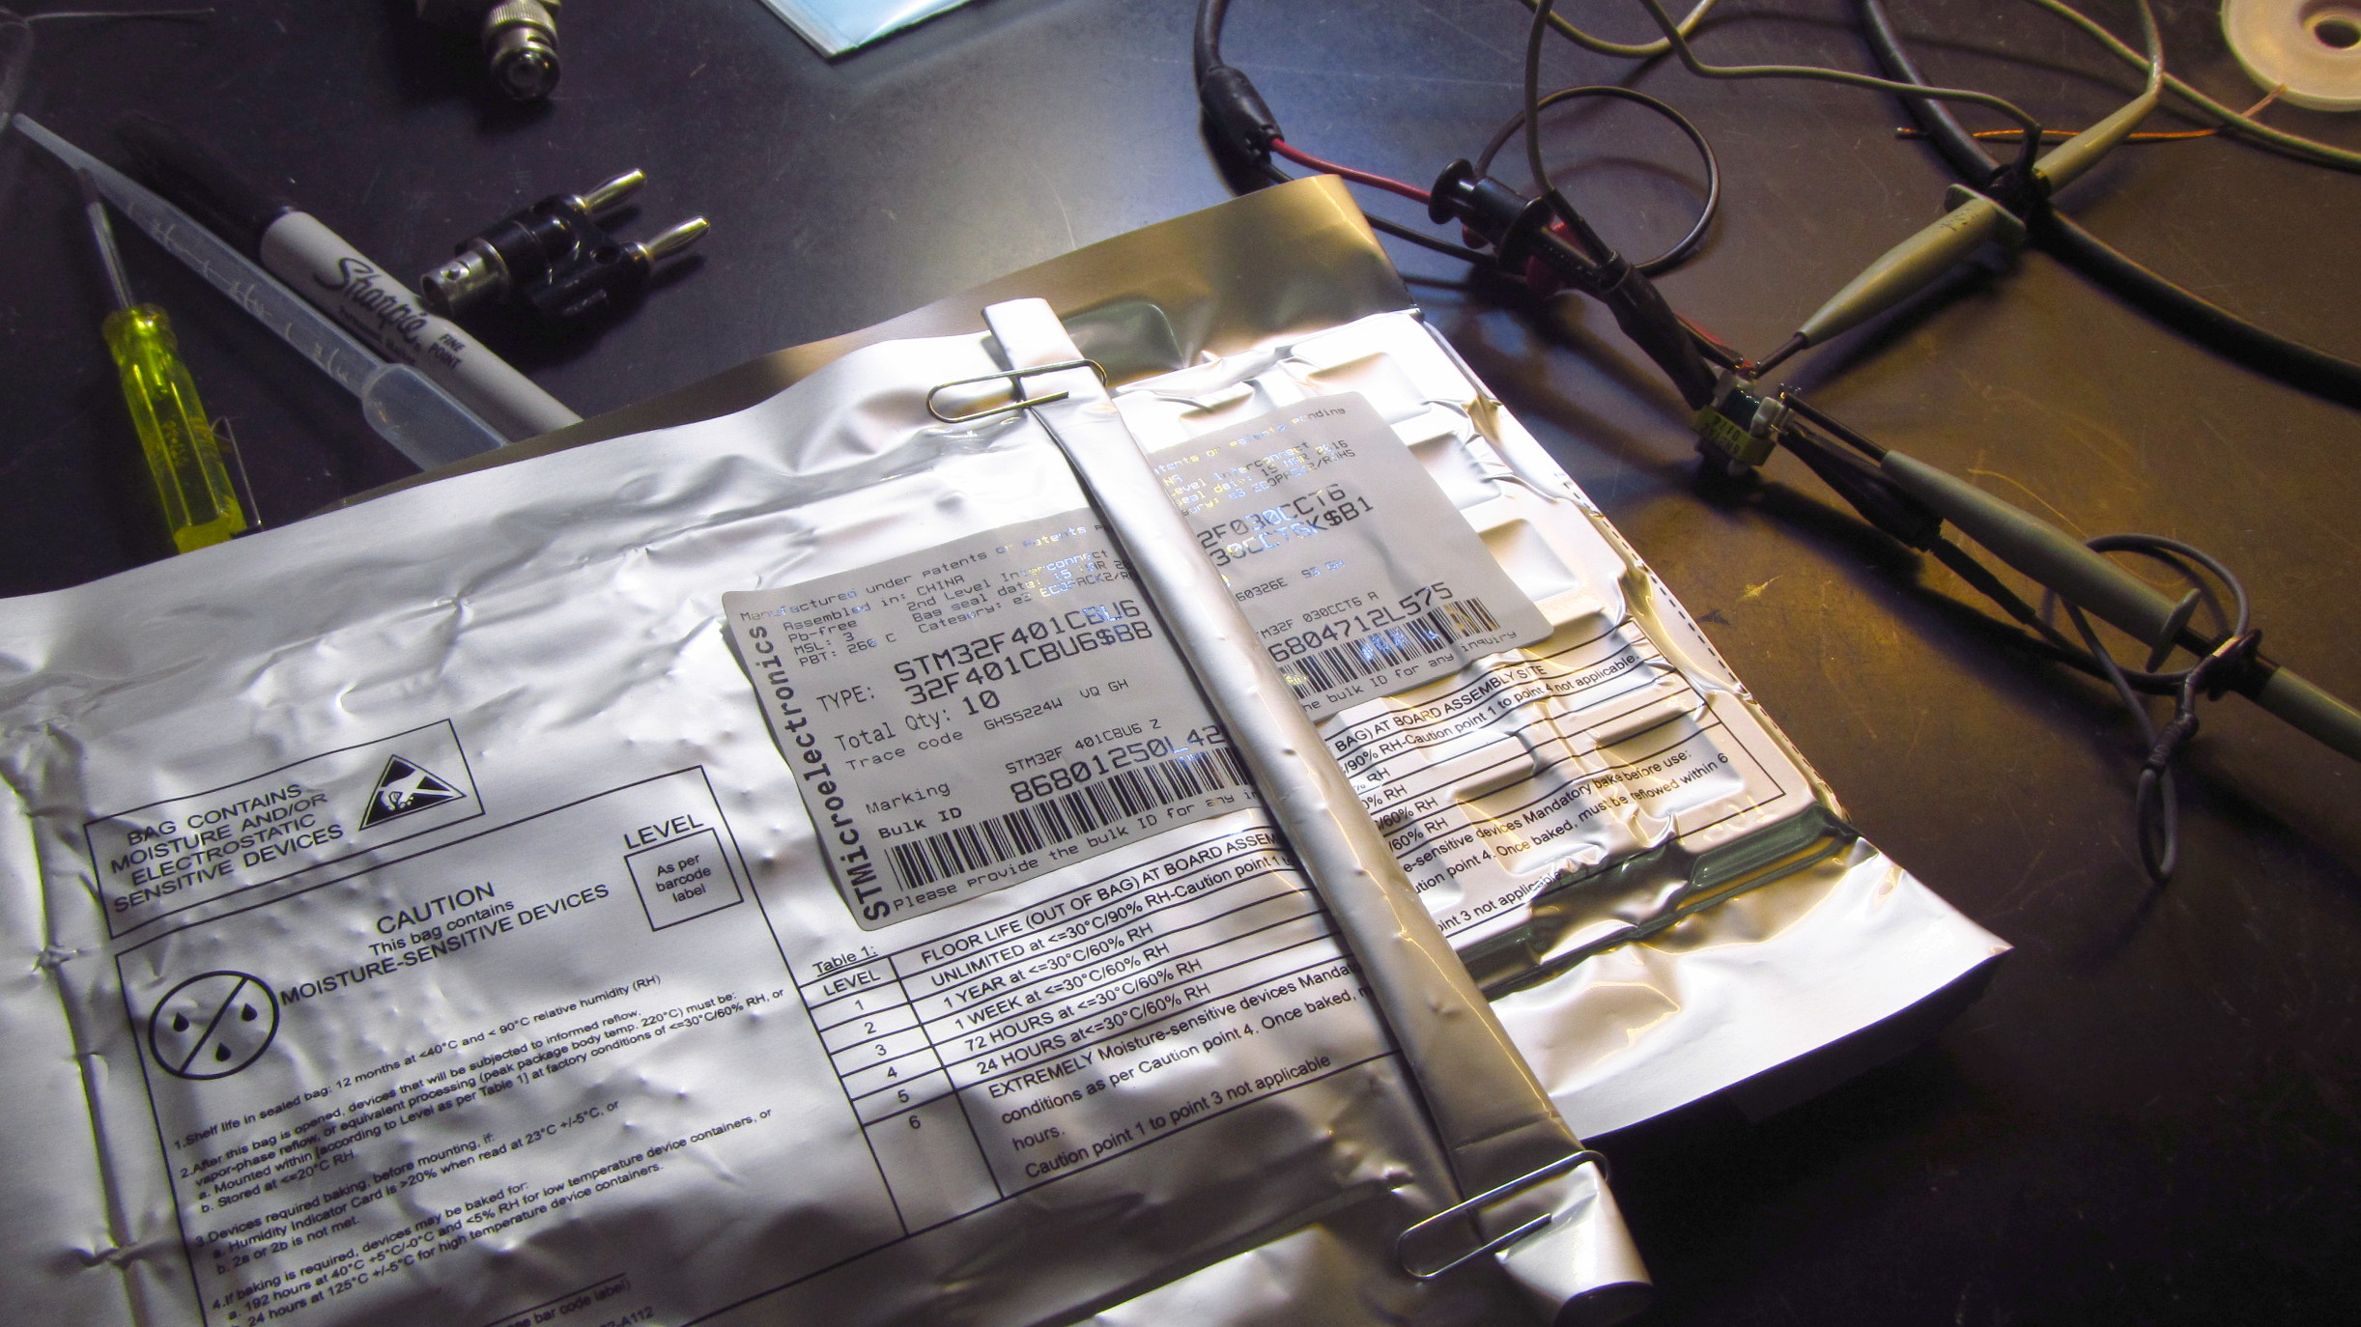

The high voltage comes in two parts, a boost circuit with active transistor switches controlled by the MCU, and an all passive but for diodes part that ratchets up the Volts. The Volt multiplier passive part is easy except for parts procuring for production – prototyping is quick with parts from digikey that can be drop in replaced with lower cost parts later. The boost circuit uses fairly ordinary transistors – they're not super cheap, but will add only a dollar or $2 to the bill of materials. What needs careful choosing is a transformer. The photo below is of a capable transformer out of a laser printer from 2003 or so being measured for turns ratio. Its ratio is 57:1.
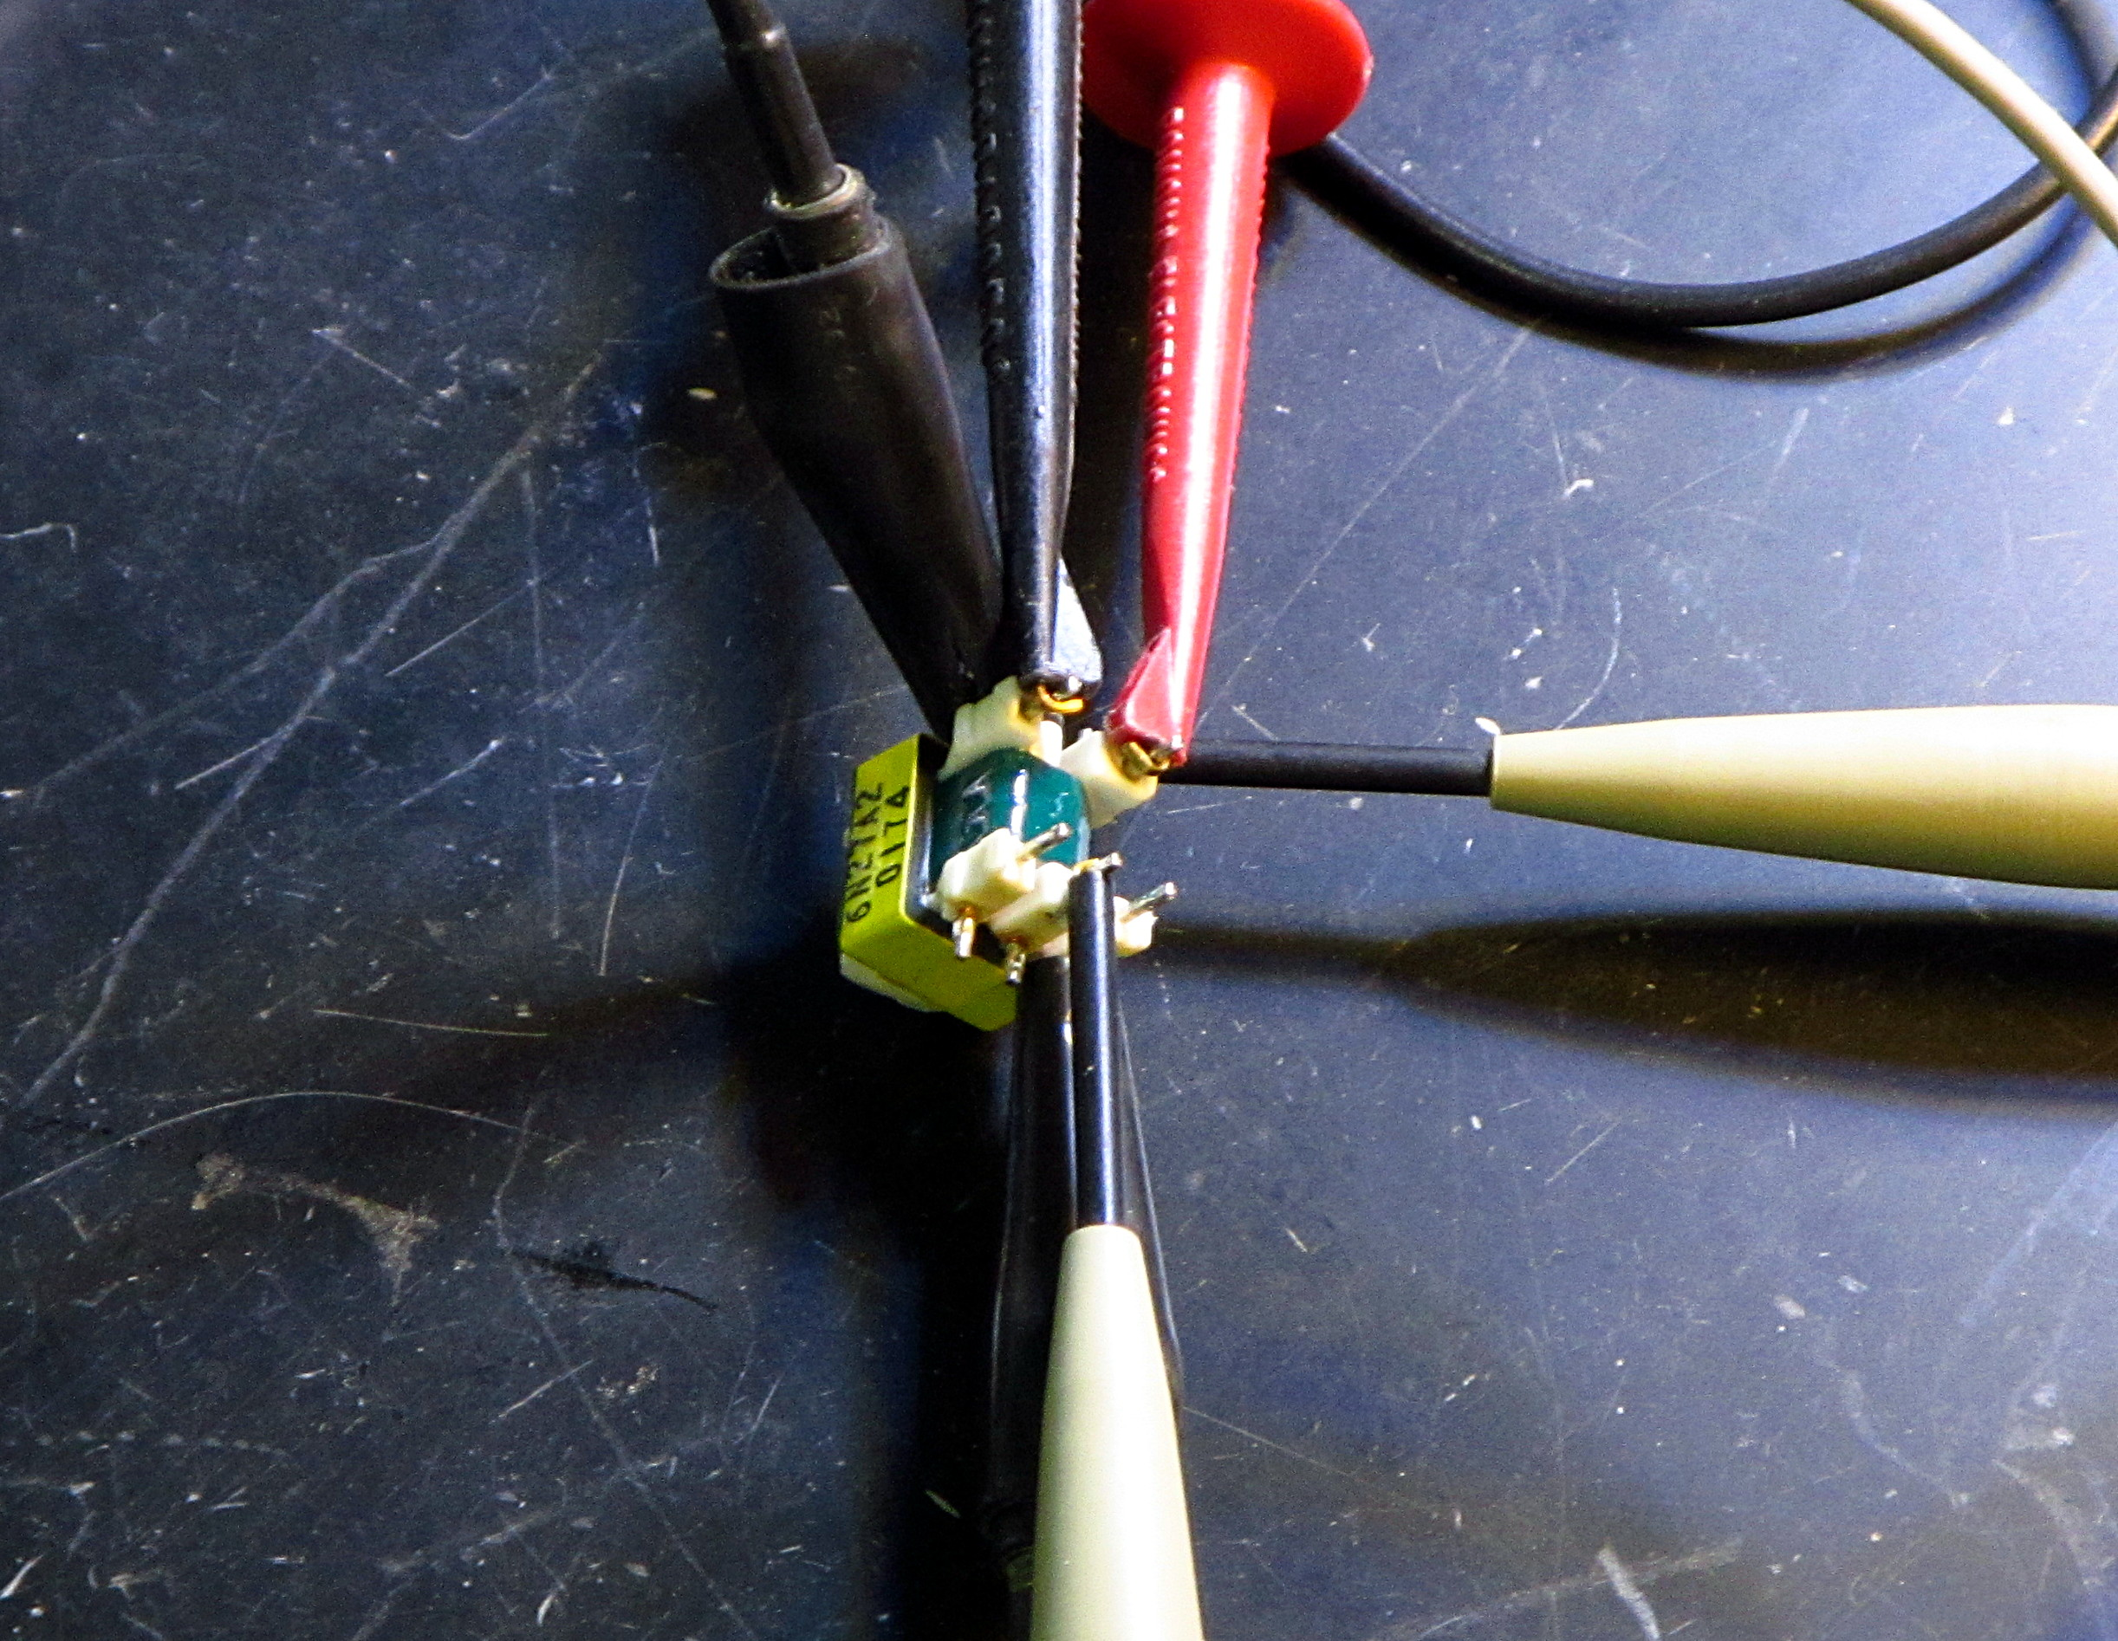

Negotiating is already started with a Chinese transformer maker about duplicating its qualities for withstanding voltage, and power throughput and small size – it's only 10mm x 17mm x 15mm tall. There are 2 others like it and others that are larger that all have the same winding arrangement – a center tapped dual input and single output with many turns and high Volts. I'll cut one open to measure wire size for a quote from China, and do some pulser tests with the others. The reason junk parts from laser printers have transformers that are the same except for size is they use a circuit called Royer oscillator. Royer oscillators have few parts and easily can be made to take off and go at a reasonable speed such as 20kHz or 30khz just above hearing. We need computer control, so that's not just what we need, but it's close variant, a resonant royer is maybe useful later to minimize noise emitted. For lab equipment that is intermittently used, some noise is OK and that will wait, but be planned for by quoting transformers with 3 windings. Transformers don't cost much as you go, but starting a new one costs, so we try to make it count for later.

Since volts are our main goal there is not much left besides LEDS and resistors used as indicators and pushbuttons and the plastic case. Communication so it can be programmed is left: USB chip CP2104 Needs no firmware, only using Silicon Labs' AN220: Driver Customization Wizard. This will create a USB device endpoint, not a host controller.
Tritech Research is a possible source of pipette/cuvette tips to use, and I have a request for phone call in today. More on that as I find out.

Part of a safe system is the enclosure. A month is not enough time to get nice plastic moldings made, so the housings will be flat sheets fastened with screws made of plastic and wood.
Code is the next thing that makes this a complete system. Micropython is a way that limited memory RAM in microcontrollers can be used to run python and chunks of C language compiled in as calls from python. It is well tested on STM32 ARM microcontrollers and is also now working with the WROOM wifi module that costs only $3. I will figure how to get the new platform working smoothly with Micropython – loading new code with low effort, and having functions to use at the prompt that are system specific and make getting a recording and logs of your zap easy. For the early adopter v1.0 one month project that will be minimal – just enough to do zaps, not fancy logs.
But all that code will be published along with the OSHW docs and be easy to update on your pyzappas.

I see no big hurdles to getting this done on time. I may get some nice enclosures started on before the month is up and if so, you will get them. You will get them anyway as they come since I offer to upgrade any pyzappa sent back to the current model up to v1.0 for free, and for the plastic case parts past v1.0 so your machines look good in the press. All I ask is you assemble the plastics yourself, or pay for shipping back to me. I'll ship it back to you at my expense.

What John Griessen dba Ecosensory would like in return for diligently developing this open source hardware is preorders paid in advance for pyzappas at $250 each. If you don't want delivery right away, that is OK, (you can have a more up to date rev 1.0 later), but I need payment in advance of commiting a month of time to the project. I will make you a receipt for money paid and purchase order. If you don't want delivery at all, but to support the project, I will make a receipt for money paid and describe it as development work for hire with open license. I'd like to do the full newly created OSHW certification by OSHWA for documentation to see what it is like.

John Griessen
1218 W 39th St.
Austin Texas 78756
john@ecosensory.com 512 451 8207

