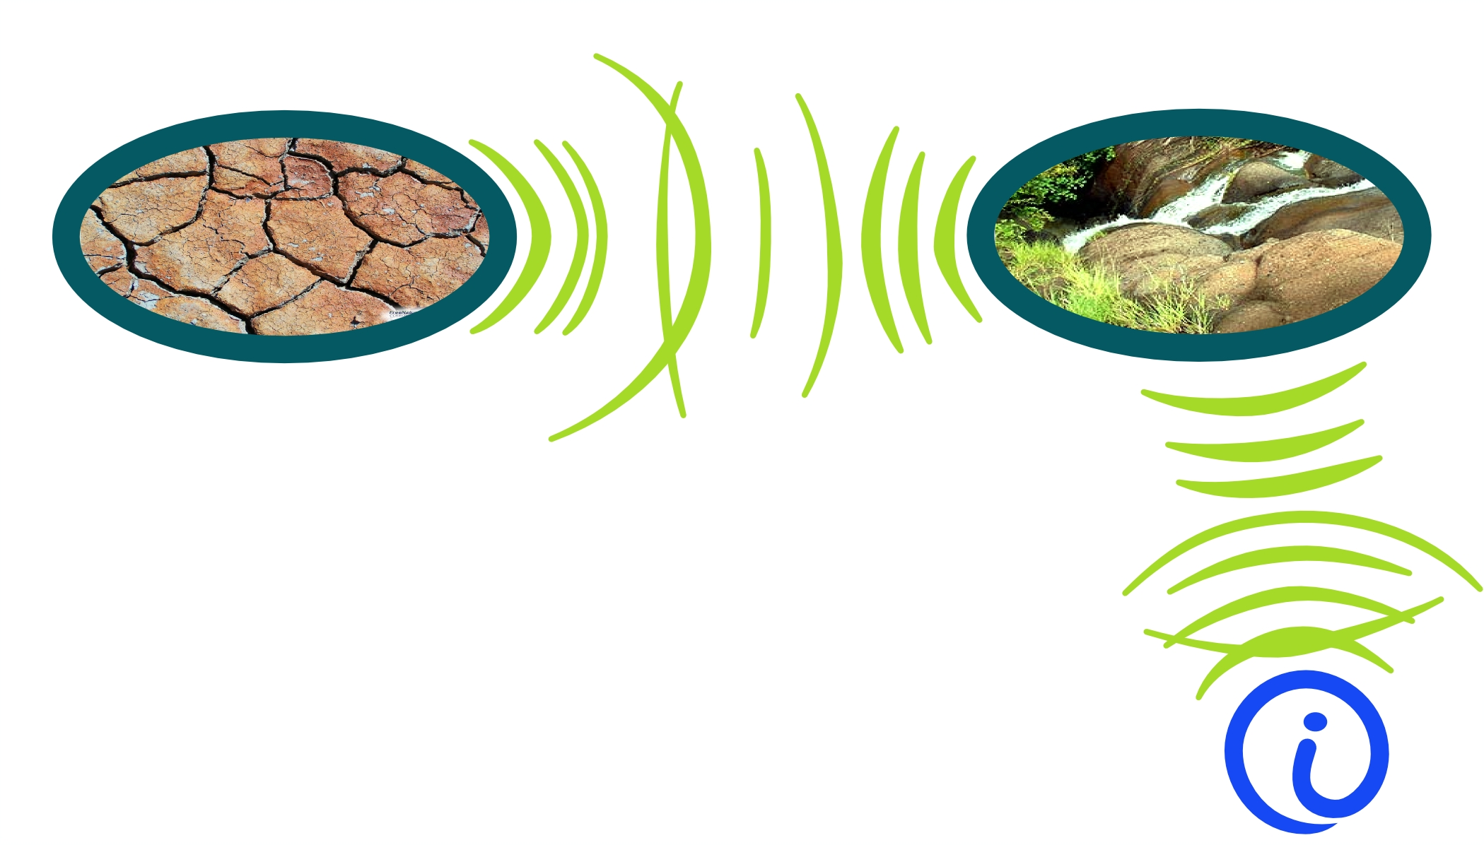
Pyzappa
Ecosensory
1218 W 39th St.
Austin Texas 78756
(512) 451-8207

Proposal to develop and deliver prototypes of an electroporator product capable of transforming bacteria for a target selling price of $125 in kit form.

There are three parts that are essential to a successful electroporator product. A user interface that is useful and simple, a voltage delivery system that can be user programmed as time varying voltage, and safety features to keep the high voltage away from human skin. The user interface planned is based on features of micropython, which will be running on the embedded microcontroller – USB port python prompt, status LEDs, command buttons. The voltage pulser will work from USB port power to charge a local LiFePO4 battery, then when commanded, boost voltage to 3000 Volts with a DC to DC 28 Volt stage, followed by a flyback 57:1 transformer switcher, and diode voltage 2X multiplier. The flyback switcher will be implemented with the microcontroller GPIOs driving FETs and bipolar transistors so as to merge a series of pulses into a jagged long pulse profile. The system safety designed in will stop danger and damage by high voltage via USB cables by not allowing a pulse to be delivered unless the USB cable is unplugged.

The sketches below show a concept of how this machine could evolve to have useful features without having too many confusing options:

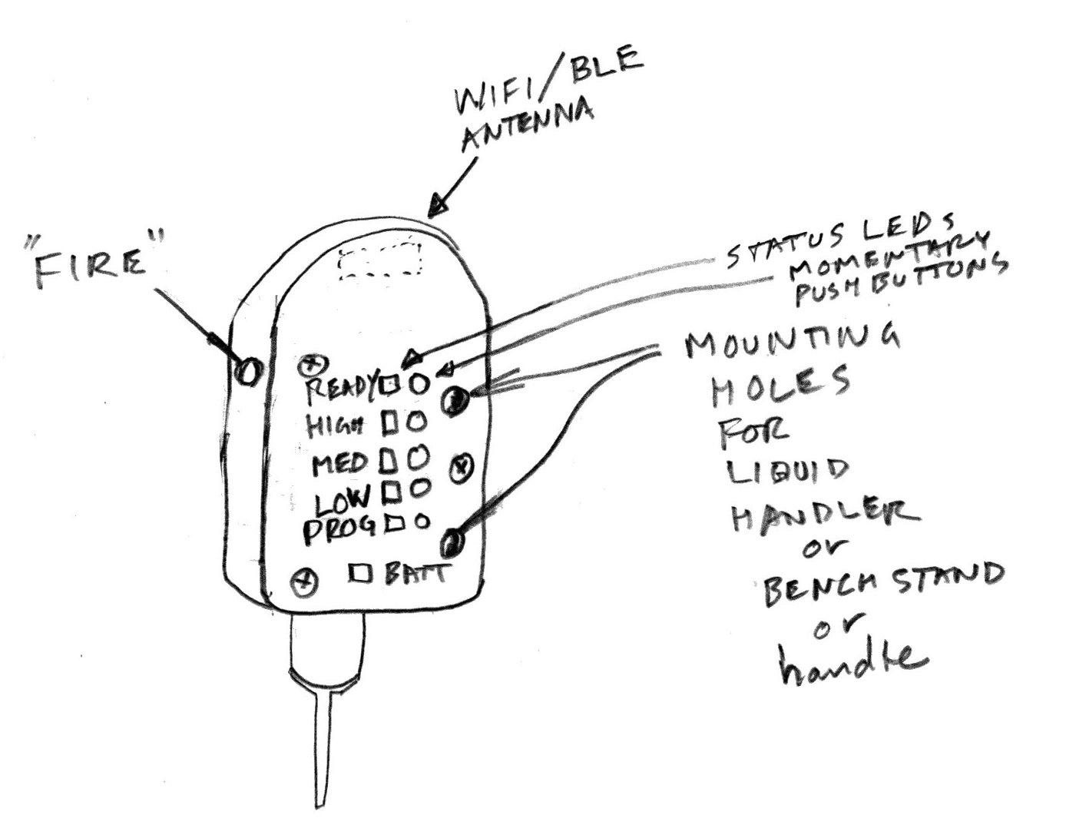
The button that fires the pulse will be away from other buttons so it is not pressed accidentally. The other buttons will each have a status LED next to them, and a label in English and a graphic. For the ready light, the button “gets it ready again” if the LED goes out; for MED HI LO PROG buttons the status LED immediately shows that the state changes when you push the button. The battery status LED has no button – to remedy a red battery status, you need to charge the battery more by plugging in the USB or the 28VDC wall wart supply. The 28V supply is not a path to computers/people safety issue, so it can be left plugged in all the time, (good for an automation application). The top of the housing has room for a WIFI radio antenna under the plastic for safely communicating to change states and fire the electroporator – good for automation also – but that won't be part of early rev 0.x or 1.0 pyzappas.

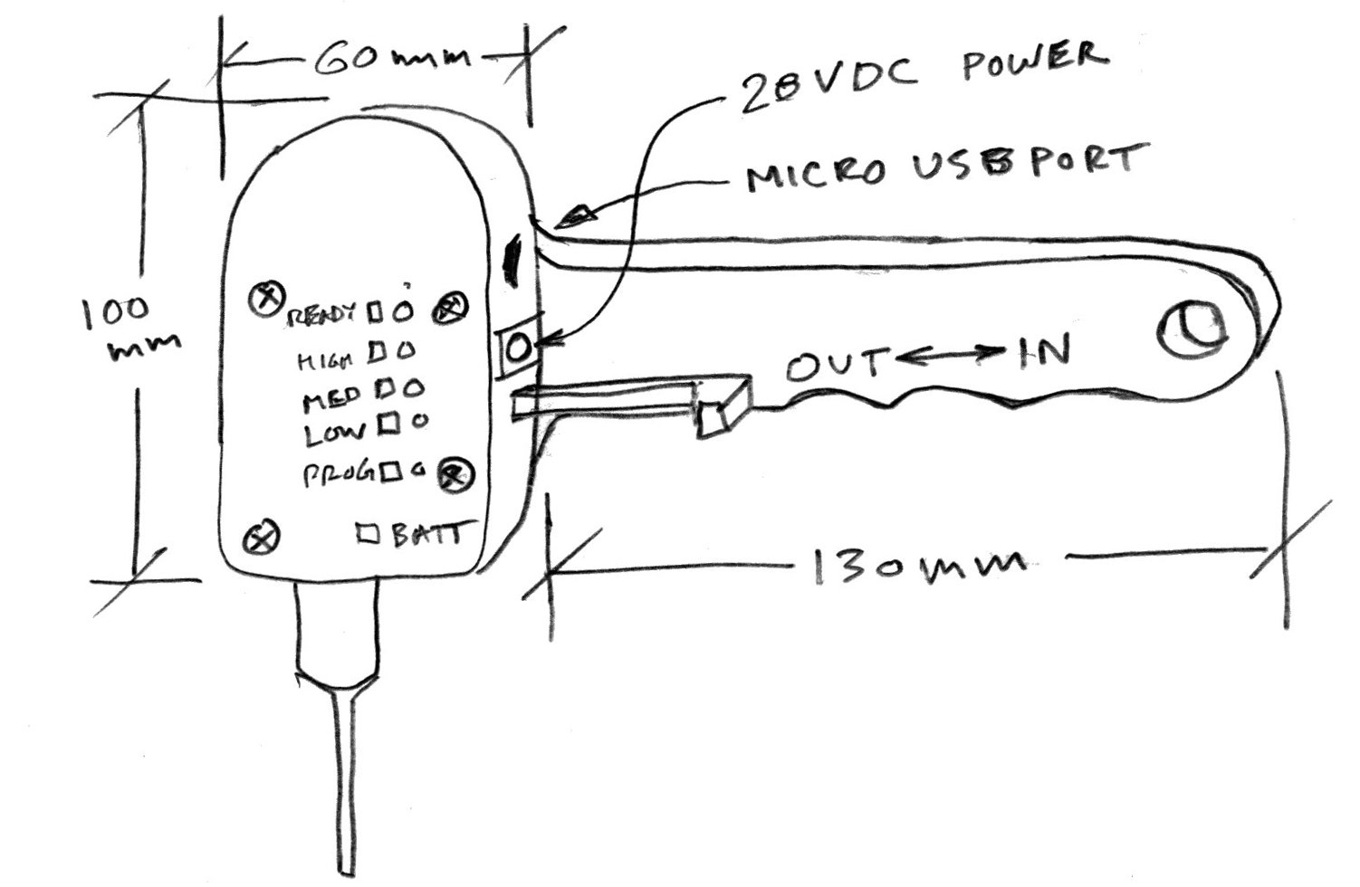
The pipette action is planned to be motorized later on and by a finger operated lever for rev 1.0 and not at all for rev 0.x pyzappas. Instead of a handle, a stand can be attached to set it on a table and move cell suspensions under it.

The circuits used for
pulse generating have been around for along time, but combining pulses to make a profile is not often seen. It will work well and be as reliable as most normal power supplies because the number of parts is low. The computer general purpose IO lines will be driving FETs so plenty of HV protection resistance in the lines is OK – no big slow down of signals. So if an FET blows, it won't take out the microcontroller.

The microcontroller planned is a STM32F030CCT6 which costs only $1.30 and can run micropython when some new platform definition work is done. If that work is too long to do for this project, another variant the STM32F401CBU6 which costs $2.8 will be used since it is already a defined micropython platform. Samples of these MCUs are in store now.
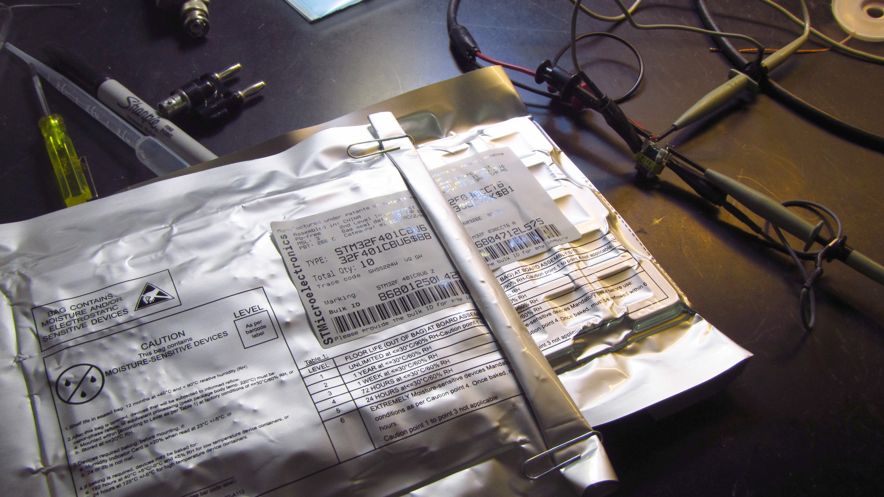

The high voltage comes in two parts, a boost circuit with active transistor switches controlled by the MCU, and an all passive but for diodes part that ratchets up the Volts. The Volt multiplier passive part is easy except for parts procuring for production – prototyping is quick with parts from digikey that can be drop in replaced with lower cost parts later. The boost circuit uses fairly ordinary transistors – they're not super cheap, but will add only a dollar or $2 to the bill of materials. What needs careful choosing is a transformer. The photo below is of a capable transformer out of a laser printer from 2003 or so being measured for turns ratio. Its ratio is 57:1.
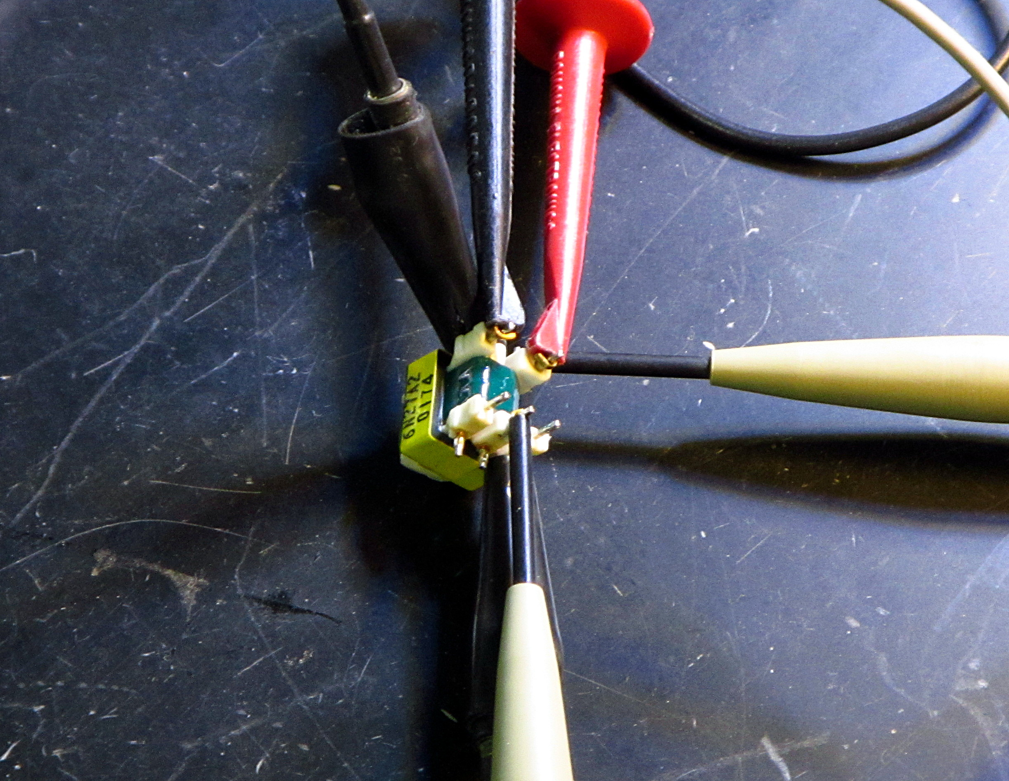

Negotiating is already started with a Chinese transformer maker about duplicating its qualities for withstanding voltage, and power throughput and small size – it's only 10mm x 17mm x 15mm tall. There are 2 others like it and others that are larger that all have the same winding arrangement – a center tapped dual input and single output with many turns and high Volts. I'll cut one open to measure wire size for a quote from China, and do some pulser tests with the others. The reason junk parts from laser printers have transformers that are the same except for size is they use a circuit called Royer oscillator. Royer oscillators have few parts and easily can be made to take off and go at a reasonable speed such as 20kHz or 30khz just above hearing. We need computer control, so that's not just what we need, but it's close variant, a resonant royer is maybe useful later to minimize noise emitted. For lab equipment that is intermittently used, some noise is OK and that will wait, but be planned for by quoting transformers with 3 windings. Transformers don't cost much as you go, but starting a new one costs, so we try to make it count for later.

Since volts are our main goal there is not much left besides LEDS and resistors used as indicators and pushbuttons and the plastic case. Communication so it can be programmed is left: USB chip CP2104 Needs no firmware, only using Silicon Labs' AN220: Driver Customization Wizard. This will create a USB device endpoint, not a host controller.
Tritech Research is a possible source of pipette/cuvette tips to use, and I have a request for phone call in today. There was no response from them, so ordinary cuvettes will be the starting point. If no wholesale pipectrodes are coming from Tritech Research, I won't spend effort and time on being able to use them. Instead I will think about similar ways and using standard commodity pipette tips plus some adapter with wires inserted – Nathan triggered that thought.

Part of a safe system is the enclosure. A month is not enough time to get nice plastic moldings made, so the housings will be flat sheets fastened with screws made of plastic and wood.
Code is the next thing that makes this a complete system. Micropython is a way that limited memory RAM in microcontrollers can be used to run python and chunks of C language compiled in as calls from python. It is well tested on STM32 ARM microcontrollers and is also now working with the WROOM wifi module that costs only $3. I will figure how to get the new platform working smoothly with Micropython – loading new code with low effort, and having functions to use at the prompt that are system specific and make getting a recording and logs of your zap easy. For the early adopter v1.0 one month project that will be minimal – just enough to do zaps, not fancy logs.
But all that code will be published along with the OSHW docs and be easy to update on your pyzappas.

I see no big hurdles to getting this done on time. I may get some nice enclosures started on before the month is up and if so, you will get them. You will get them anyway as they come since I offer to upgrade any pyzappa sent back to the current model up to v1.0 for free, and for the plastic case parts past v1.0 so your machines look good in the press. All I ask is you assemble the plastics yourself, or pay for shipping back to me. I'll ship it back to you at my expense.

What John Griessen dba Ecosensory would like in return for diligently developing this open source hardware is reorders paid in advance for pyzappas at $250 each. If you don't want delivery right away, that is OK, (you can have a more up to date rev 1.0 later), but I need payment in advance of committing a month of time to the project. I will make you a receipt for money paid and purchase order. If you don't want delivery at all, but to support the project, I will make a receipt for money paid and describe it as development work for hire with open license. I plan to do the full newly created OSHW certification by OSHWA for documentation to see what all that is like.

Bryan Bishop says he is interested in equity in an open electroporator, but I'm not interested in giving out such ownership rights. I have no corporations set up and don't see doing that until substantial money flows out of a good product design, so there is no limited way to own some of me – and I don't go for perpetual ownership of any sliver of my output. I will make time limited agreements about product sales income that is similar to equity, but not exactly that definition. Say William and Nathan are still OK with $250 each, that leaves $1500 to get to a bare bones pyzappa without much of a case – maybe some sawn /glued wood and plastic boxes and lids,
but a nice user interface and programmability and safety and ready to supply as a kit for ongoing sales. Without cooperation from Tritech, there will be no time in a month for any new plastic molding experiments – that will be needed for standard cuvette contact/hold/safety-shield work. Appendix A is a feature list and specification for what the pyzappa v1.0 will be. For a $1500 product-only-investment from Bryan, I will offer product specific ownership of future sales income proportionately to how a project like this is normally spent on to get to completion. Such a project costs $50k in the free market world with no value attached to OSHW free publishing, and done with employees for design steps and subs for parts fabbing. Pyzappa v1.0 is 1/5 of the way to that, but the payment is only 3% of the market price towards the goal, so ownership is offered at that fraction. I offer for the next three years, (much later than the likely product life-cycle crossing the chasm phase – the end of life wind-down phase), 10% of profits paid back for any v1.0 pyzappa sold, paid monthly after bookkeeping, up to a max of 6% of 50k, or $3000,
which is a 100% ROI over 3 years. After that time, especially for an OSHW product, sales will be hardly any and all product sold will be the newer versions except for some lo priced kits. As volume goes down after the mainstream phase, the bookkeeping becomes too much of a burden, so all payments for that old trickling income product cease at the 3 year mark. There is no ownership offered of any other of my output, and there may be no corporation formed unless sales go up to a good rate, say $40k/year. This agreement can be sold to someone else and I will pay them for the remaining time.

John Griessen
1218 W 39th St.
Austin Texas 78756
john@ecosensory.com 512 451 8207

Appendix A Feature List and Specification for Electroporator PyZappa v1.0
Programming will be via USB device endpoint for serial ports, and referencing micropython documentation, plus a quick how-to published on kitmatic.com under the product docs section.
Power will be by 28 Volt “wall wart” external UL listed power supply.
Output zaps will be disabled when USB is plugged in – no USB remote controlling, (safety reasons).
Programmability of output zaps will be by a sequence of python commands that do not guarantee a definite pulse shape. Pulse shape will have to be arrived at by trial and error, using external observations with oscilloscopes to a voltage divided down test point that is inherently not safe to touch, and the whole oscilloscope is not safe when using it to observe the HV discharges. The reason it is not safe is the voltage divider chain of resistors could fail conductive-→oscilloscope gets zapped-→people touching oscilloscope usually.
Micropython running on a STM32F030CCT6 which costs only $1.30 or STM32F401CBU6 which costs $2.8 will power the sequence and control functions.
Indicator LEDs and pushbuttons will be provided for Ready, High, Medium and Low states of the machine. The Ready LED will be red or green and when red, pushing Ready button “gets it ready” for the next zap. High, Medium and Low pushbuttons change to different stored zap profiles named High, Medium and Low.
Fire button causes a discharge.
Batt indicator LED is low duty cycle blinking red when battery needs charging soon.
Standard electroporation cuvettes with aluminum contacts will be connected somehow to the zap output such that high voltage cannot jump a gap to to where the cuvette mounts when a safety guard is removed for loading and unloading cuvettes by hands. The safety guard lid will probably operate like a knife switch where contacts, are more than 7mm apart and are bridged by a copper strip, (or pogo pins), when the lid is pushed on. When the lid is open, no bare contacts will have high voltage on them. Bare metal with HV might be present inside a 3mm hole that a pogo pin goes into, or inside a 1.5mm insulated slot that a copper strip goes into to make contact. Fingers randomly touching the cuvette area would not touch anything but insulator and have an air gap to HV of more than 7mm.
The overal size will be less than 10cm X 10cm X 5cm tall if using electroporation cuvettes, and smaller if using pipectrodes.
local LiFePO4 battery, circuits to charge it, detect state ofcharge.
Flyback switching power supply with flyback 57:1 transformer to generate at least 3kV into a 30kOhm load starting from the low 3.2V of the LiFePO4 battery, or the 28VDC external power supply.
28VDC external power supply (from AC 120V). Either/or a 28VDC external power supply (from AC 240V).

